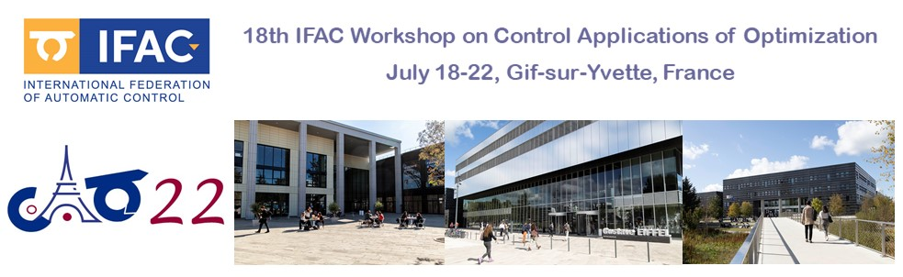

Gif-sur-Yvette, July 18, 2022

Confirmation of Participation

Attendee information:

- Last name: xxxxx
- First name: yyyyy
- Email: zzzzz@zz.zz
- Title: Prof/Dr
- Phone number +09090909
- Country dsdsdsdqsd
- Mailing Address: dsdsdsdqsd
- Institution dsdsdsdqsd

Event information:

- Event dates: 18-22 July 2022
- Event name: 18th IFAC Workshop on Control Applications of Optimization
- Event location: CentraleSupélec, Paris-Saclay, Gif sur Yvette, France

Payment information:

- Registration amount: 00000 EUR
- Used payment type Payment online/bank transfer
- Transaction: ……………. (to be filled in by the organizers)
- Date of transaction ……………. (to be filled in by the organizers)

By the present paper, we confirm the above identified participant took part to the technical program of IFAC CAO with a communication entitled:

- “SQooqoqo oqooqojojjjoooo”

